Logical Operations

Arithmetic and logical operations are performed in the CPU by the Arithmetic/Logical Unit (ALU). SAL arithmetic instructions were previously introduced. Logical instructions are bit-oriented manipulations of data based on the mathematical logic operations and, or, and not.

Logical operations are applied to boolean variables which have two values: true and false, or 1 and 0.

Logical operations are defined by a truth table.

The unary not operation applied to a boolean variable, a, is the complement of a, The truth table for not a is:
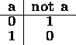

The basic binary logical operations are:
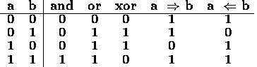

The complements of these binary logical operations are also commonly used:
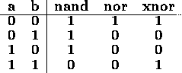

A total of 16 different binary logical operations are possible. In addition to those above, operations which simply produce a, b, or true, and the complements of these operations, may also be defined.

The SAL logical operations are:

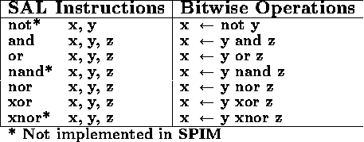

Notes:
- The operands x, y, and z must be declared as .word.
- Logical operations are performed bitwise on the operands.
- Although listed in the text, the operations not, nand, and xnor are not implemented in the SPIM simulator.
- Pascal has no equivalent bitwise operations.

Logical operations are used to set, clear or complement selected bits using a mask.

When four ASCII characters are stored in a 32 bit word, any single character may be extracted using a mask. Suppose the location cell contains the characters 'Char' from left to right. The hexadecimal value of cell is 0x43686172.

The rightmost 'r' of cell may be extracted by performing the and operation on cell with the mask 0x000000FF.

The and operation clears (sets to 0) the bits which correspond to 0's in the mask and leaves the bits corresponding to 1's unchanged.

For example, the SAL instruction

and result, cell, 0x000000FF

would assign result the value 0x00000072, which is the character 'r'.

To replace one character with another, the old character is first cleared using a mask and then the new value is merged using the or operation.

The SAL instructions

and result, cell, 0xFFFFFF00

or result, result, 0x00000074

change the rightmost 'r' of cell to a 't' producing 'Chat' in result.

The or operation sets the bits which correspond to 1's in a mask and leaves the bits corresponding to 0's unchanged.

For example, the SAL instruction

or result, cell, 0x20202020

changes all alphabetic characters in cell to lowercase and assigns 'char' to result by turning on the bit for lowercase ASCII characters.

The xor operation reverses the bits which correspond to 1's in a mask and leaves the bits corresponding to 0's unchanged.

For example, the SAL instruction

xor result, num, 0x80000000

reverses the sign bit of num and assigns the new value to result.

The SAL instruction

xor result, cell, 0x20202020

reverses the case of all alphabetic characters in cell and assigns 'cHAR' to result.

To complement all the bits in a word, the xor operation can be performed with a mask of 0xFFFFFFFF.

Shift Operations
If is often necessary to align bits in a certain position in a word. The shift operations allow bits to be moved to the left or right in a word. There are three types of shift operations: logical, rotate and arithmetic.
A logical shift moves bits to the left or right. The bits which 'fall off' the end of the word are discarded and the word is filled with 0's from the opposite end. A logical right shift of the 8 bit binary number 1000 1011 gives 0100 0101, as shown below:

Shift instructions include a repeat value, which is the number of times the single bit shift operation is repeated.
A rotate operation is a circular shift in which no bits are discarded. A rotate right of the 8 bit binary number 1000 1011 gives 1100 0101, as shown below.

A right rotation by n bits of an n bit word returns the original word unchanged. A right rotation by n-1 bits is equivalent to a left rotation of 1 bit. The left rotation instruction is redundant because a left rotation of j bits is equivalent to a right rotation of n-j bits.
On positive integers, a logical left shift is equivalent to multiplication by 2 and a logical right shift is equivalent to division by 2. The arithmetic shift extends this operation to negative 2's complement integers.
An arithmetic right shift is similar to a logical right shift, except that the leftmost bits are filled with the sign bit of the original number instead of 0's.
An arithmetic right shift of the 8 bit number 1000 1011 gives 1100 0101, as shown below:

Observe that in 8 bit 2's complement 1000 1011 equals decimal -117 and the result after the arithmetic right shift is 1100 0101, which equals decimal -59.
The SAL shift instructions are:
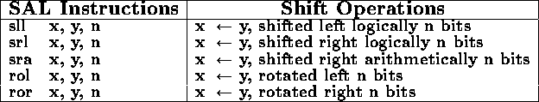
There are no Pascal operations equivalent to these shift operations.
Shift operations may be combined with logical operations to extract and align bit fields. For example, the exponent of an IEEE floating point number, F, may be extracted as follows:
and E, F, 0x7F800000 # mask the exponent field
srl E, E, 23 # shift exponent to the right
sub E, E, 127 # convert from biased-127
In this example, E and F are both words.
Values in memory may be converted to hexadecimal using mask and shift operations. For example, the leftmost hexadecimal digit in a word, I, may be printed as follows:
.data
I: .word # the number to be printed
T: .word # temporary to hold hex digit
C: .byte # hex digit in ASCII
.text
__start:
get I # read a number
and T, I, 0xF0000000 # mask leftmost hex digit
rol T, T, 4 # rotate to bits 0-3
move C, T # truncate to byte
add C, C, '0' # convert to ASCII
ble C, '9', print # check for A-F
add C, C, 7 # convert A-F to ASCII
print: put C # print hex digit
done
By adding a loop which rotates I by 4 bits to the left on each iteration, an entire word may be printed in hexadecimal form.

